Impact of Deployment Topology on the Performance Trade-off Between IRS versus Decode-and-Forward Relaying in Wireless Communication Systems
Marvin A. Guantero ¹ and Aaron Don M. Africa¹*
¹ Department of Electronics, Computer, and Electrical Engineering, De La Salle University, Manila 1004, Philippines
Email: marvin_guantero@dlsu.edu.ph (M.A.G.); aaron.africa@dlsu.edu.ph (A.D.M.A)
*Corresponding author

Abstract—Intelligent reflecting surfaces (IRS) have emerged as a promising technology for enhancing wireless communication system performance by passively reflecting incident signals toward intended receivers through software-controlled phase shifting. While prior work has established analytical frameworks comparing IRS-assisted communication against conventional decode-and-forward (DF) relaying, existing analyses have predominantly relied on fixed deployment geometries, leaving the critical question of where to place these devices largely unexplored. This study investigates the impact of deployment topology on the performance trade-off between IRS and DF relaying in terms of required transmit power, signal-to-noise ratio, achievable rate, and energy efficiency. Using Monte Carlo simulations across 10,000 randomized placements and systematic parameter sweeps based on the 3GPP Urban Micro channel model, we demonstrate three key findings: (1) IRS and DF relay exhibit fundamentally different optimal placement strategies, with IRS favoring asymmetric near-endpoint placement while DF relay favors balanced mid-point positioning; (2) the power advantage of IRS over relaying varies by more than 15 dB depending on placement geometry; and (3) a topology-dependent optimal number of IRS elements exists that balances passive beamforming gain against circuit power consumption. These results provide practical deployment guidelines for communication system engineers evaluating IRS versus relay-assisted architectures and demonstrate that node placement is a first-order design variable that cannot be neglected in performance comparisons.

Keywords— Intelligent reflecting surface, reconfigurable intelligent surface, decode-and-forward relay, deployment topology, node placement optimization, link budget, path loss, transmit power minimization, energy efficiency, signal-to-noise ratio, 3GPP Urban Micro, Monte Carlo simulation, wireless communication systems, cooperative communication, coverage planning.

Introduction
The ever-increasing demand for higher data rates, broader coverage, and improved energy efficiency in wireless communication systems has driven the exploration of novel technologies beyond conventional
transceiver architectures. Among the most actively researched innovations in recent years is the intelligent reflecting surface (IRS), also referred to as a reconfigurable intelligent surface (RIS). An IRS consists of a planar array of passive reflecting elements, each capable of inducing a controllable phase shift on the incident electromagnetic signal. By jointly optimizing these phase shifts, the IRS can constructively combine reflected signals at the destination, thereby enhancing the received signal-to-noise ratio (SNR) without requiring active radio-frequency chains, power amplifiers, or signal processing hardware [1], [2], [3]. A comprehensive signal processing perspective on reconfigurable intelligent surfaces and their wireless applications is provided in [4].
The appeal of IRS in communication systems lies in its potential to reshape the wireless propagation environment rather than merely adapting to it. Unlike conventional decode-and-forward (DF) relays [5], which receive, decode, re-encode, and retransmit signals using dedicated hardware with significant power consumption, an IRS operates as a nearly passive device. This distinction has profound implications for the link budget, power consumption, and deployment cost of communication systems. The energy efficiency advantages of reconfigurable surfaces have been analyzed in [6], where it was shown that IRS can improve the energy efficiency of wireless communication systems under certain conditions. However, the passive nature of IRS also means that each reflecting element provides only a small contribution to the overall channel gain. The path loss characteristics of IRS-assisted links have been experimentally validated by Tang et al. [7], confirming the theoretical product-distance path loss model.
The seminal work by Björnson, Özdogan, and Larsson [8] rigorously quantified the IRS-versus-relay trade-off, deriving closed-form expressions for the minimum number of IRS elements required to out-
perform a single-antenna DF relay in terms of both transmit power and energy efficiency. Their analysis revealed that IRS requires surfaces with hundreds of elements to match the performance of active relaying - a finding with significant practical implications. The underlying physics of IRS propagation and the reconfigurable design principles supporting these results are further discussed in [9].
However, the analysis in [8] was conducted under a fixed deployment topology, with the IRS and relay co-located at a single predetermined position ( 80 m from the source). In practical communication system deployment, the physical placement of infrastructure nodes is one of the most consequential design decisions an engineer can make, as it directly governs the path loss on every communication link. The channel capacity of any communication link, as established by Shannon [10], is fundamentally limited by the SNR, which itself is determined by the path loss model and thus by the distance between nodes. Standardized path loss models such as the 3GPP Urban Micro (UMi) model [11] quantify this relationship precisely. The importance of IRS placement has been recognized by You et al. [12], who investigated whether IRS should be deployed on the base-station side, user side, or both, though their analysis focused on a different system model. The question of optimal relay placement has also been studied in conventional relay networks [13], [14], but these results do not directly transfer to IRS due to the fundamentally different signal model.
This paper extends the work of Björnson et al. [8] by systematically investigating the impact of deployment topology on the IRS-versus-relay performance comparison. Through parametric sweeps and Monte Carlo simulations over thousands of deployment geometries, we reveal that IRS and DF relay have fundamentally different optimal placement strategies and that the performance gap between them is highly sensitive to node positioning.

Background of the study
- Intelligent Reflecting Surfaces
An intelligent reflecting surface is a two-dimensional metasurface composed of N subwavelength reflecting elements, each of which can independently adjust the phase (and ideally the amplitude) of the reflected signal [1], [4]. When the phase shifts are optimally configured to align the reflected signal components coherently at the receiver, the IRS provides a passive beamforming gain that scales with $N^{2}$ in terms of received power. This quadratic scaling arises because the IRS creates N coherently combined signal paths from source to destination via the surface. Wu and Zhang [15] demonstrated that joint active and passive beamforming optimization can significantly enhance the achievable rate of IRS-assisted systems. The
end-to-end channel gain for an IRS-assisted link can be expressed as [8]:
$$β_{IRS}={\left(\sqrt{β_{SD}}+Nα\sqrt{β_{SR}β_{RD}}\right)}^{2} (1)$$
where $β_{SD},β_{SR}$, and $β_{RD}$denote the channel gains of the source-to-destination, source-to-IRS, and IRS-to-destination links, respectively, and α is the amplitude reflection coefficient of each IRS element. This expression reveals that the IRS channel gain depends on the product $β_{SR}⋅β_{RD}$, which is fundamentally a function of the deployment geometry. In practice, accurate channel estimation is required to achieve this coherent combining, and the challenges associated with estimating the cascaded IRS channel have been surveyed in [16]. Multi-user extensions of IRS-assisted communication, including channel estimation and beamforming design, have been studied in [17].

- Decode-and-Forward Relaying
Decode-and-forward relaying is a well-established cooperative communication technique first formalized by Laneman, Tse, and Wornell [5], in which an intermediate node receives the source signal, fully decodes it, re-encodes it, and forwards it to the destination. Unlike IRS, the DF relay is an active device with its own power amplifier and signal processing capability. The achievable rate of a half-duplex DF relay system is limited by the weaker of its two hops:
$$R_{DF}=\frac{1}{2}\log_{2}\left(1+min\left\{{SNR}_{SR},{SNR}_{RD}\right\}\right) (2)$$
The factor of 1/2 reflects the half-duplex constraint, requiring two time slots for one complete transmission. The optimal placement for a DF relay is one that balances the two-hop SNRs, as the overall performance is bottlenecked by the weaker link [13]. This suggests a mid-point placement strategy, which stands in contrast to the IRS placement strategy implied by (1). Optimal relay station placement has been studied in the context of broadband wireless access networks by Lin et al. [14], who showed that relay positioning significantly affects network throughput and coverage - a principle that motivates the topology analysis in this work.
The weighted sum-rate maximization problem for IRS-aided networks, which provides additional context for comparing IRS and relay performance, has been addressed in [18], while uplink sum-rate maximization with IRS assistance has been studied by Zeng et al. [19].

- The Role of Path Loss and Topology
In any wireless communication system, the channel gain between two nodes separated by a distance d is governed by a path loss model. The theoretical foundation for this relationship traces back to Shannon's mathematical theory of communication [10], which
established that channel capacity is a logarithmic function of the SNR and thus is ultimately constrained by the signal attenuation across the propagation path. The 3GPP Urban Micro (UMi) model [11], used in [8] and in this work, specifies:
$$\begin{aligned}{PL}_{LOS}(d)=28+20\log_{10}⁡\left(f_{c}\right)+22\log_{10}⁡(d)\#(3)\end{aligned}$$
$$\begin{aligned}{PL}_{NLOS}\left(d\right)=22.7+26{\log_{10}\left(f_{c}\right)}+36.7\log_{10}\left(d\right) \left(4\right)\end{aligned}$$

where $f_{c}$is the carrier frequency in GHz and $d$ is the distance in meters. Since both the IRS cascaded gain in (1) and the DF relay bottleneck in (2) are directly determined by the distances $d_{SR},d_{RD}$, and $d_{SD}$, the deployment topology is not a secondary consideration but a primary determinant of communication system performance. The significance of sustainable, energy-efficient deployment in next-generation networks has been emphasized in [20], further motivating the topology-aware analysis presented here. Despite the recognized importance of node placement, the original analysis in [8] employed a single fixed topology, leaving the topology-dependent behavior unexplored.

Statement of the Problem
The comparative analysis of IRS-assisted and DF relay-assisted communication systems presented by Björnson et al. [8] provides fundamental analytical insights into the number of IRS elements required to outperform conventional relaying. However, the study is conducted under a single, fixed deployment geometry in which the IRS and relay are co-located at a distance of $d_{SR}=80 m$ from the source, with the destination varying only along one axis. While other works have examined IRS deployment strategies [12] and relay placement [13], [14], no prior study has systematically compared how topology affects the relative performance of IRS versus DF relaying across a comprehensive range of geometries. This fixed-topology assumption raises several unanswered questions that are critical for practical communication system deployment:
- Placement sensitivity: How sensitive is the IRS-versus-relay performance comparison to the physical location of the IRS or relay? Does the conclusion that IRS requires hundreds of elements to beat relaying hold across all deployment geometries, or is it topology-dependent?
- Optimal positioning: Where should an IRS or relay be placed to minimize the required transmit power or maximize energy efficiency? Do IRS and DF relay share the same optimal placement, or do they require fundamentally different deployment strategies?
- Statistical robustness: In real-world deployments where exact node placement may be constrained by physical infrastructure, what is the
probability that IRS outperforms relaying across a distribution of random placement scenarios?
- Energy-efficient sizing: Given a specific topology, what is the optimal number of IRS elements that balance passive beamforming gain against circuit power consumption [6], and how does this optimum shift with placement? These questions are fundamentally communication system design problems, as they concern the path loss, link budget, SNR, achievable rate, and energy efficiency - all core metrics of any wireless communication system [10]. This study addresses these gaps through systematic topology analysis using Monte Carlo simulations and parametric sweeps grounded in the 3GPP UMi channel model [11].

Significance of the Study
This study contributes to the field of wireless communication systems in several important ways.
For communication system engineers and network planners, this work provides the first systematic analysis of how IRS and relay placement affects the comparative performance of these two cooperative communication technologies. The finding that IRS favors asymmetric near-endpoint placement while DF relay favors balanced mid-point placement [13] is a directly actionable deployment guideline. The two-dimensional heatmap produced by the simulations serves as a coverage planning tool, visually delineating the geographic regions where IRS deployment offers a link budget advantage over relaying. This complements the deployment-side analysis by You et al. [12] by introducing the relay as a competing benchmark.
For the academic research community, this study demonstrates that the fixed-topology assumption commonly employed in IRS performance analyses [8], [15], [18] can lead to incomplete conclusions. By showing that the IRS power advantage over relaying varies by more than 15 dB depending on placement geometry, we establish that topology is a first-order design variable that must be incorporated into future analytical and simulation-based studies. The Monte Carlo framework developed in this work, which evaluates 10,000 random deployment scenarios, provides a reusable statistical methodology for topology-aware performance evaluation in communication systems. This methodology can be extended to multi-user scenarios [17] and systems with imperfect channel knowledge [16].
For the broader field of communication systems, this work reinforces the fundamental principle that the physical-layer performance of any wireless link is governed by its geometry through path loss [11], [7]. The Friis transmission equation and standardized 3GPP channel models are the backbone of communication system design, and this study applies them rigorously to answer a practical deployment question. The result that an optimal, topology-dependent number of IRS
elements exists - balancing passive beamforming gain against circuit power consumption - provides insight into the energy-efficient design of future green communication systems [20], [6], a key objective of 5G-Advanced and 6G standardization efforts.
For students and educators in communication systems, this work bridges theoretical IRS analysis with practical deployment considerations, demonstrating how core communication system concepts such as link budget analysis, SNR computation, Shannon capacity [10], and energy efficiency metrics are directly applied to evaluate an emerging technology. The simulation code, built upon the publicly available codebase of Björnson et al. [8], is fully reproducible and can serve as an educational resource.

Objectives
A. General Objective
To investigate and quantify the impact of deployment topology on the comparative performance of intelligent reflecting surface (IRS)-assisted and decode-and-forward (DF) relay-assisted wireless communication systems in terms of transmit power, signal-to-noise ratio, achievable rate, and energy efficiency using Monte Carlo simulations and parametric sweeps based on the 3GPP Urban Micro channel model.
B. Specific Objectives
The specific objectives of this study are as follows:
- To analyze the sensitivity of required transmit power to IRS and relay placement by sweeping the source-to-IRS/relay distance ($d_{SR}$) across a range of $5-150 m$ and comparing the resulting link budgets for SISO, IRS-assisted, and DF relay-assisted communication systems.
- To evaluate the impact of off-axis destination positioning by varying the vertical offset ($d_{v}$) from $1-80 m$, thereby quantifying how the geometric relationship between the IRS/relay and the destination affects the received SNR and required transmit power.
- To determine the probability that IRS outperforms DF relaying across random deployment scenarios by conducting Monte Carlo simulations over 10,000 uniformly distributed IRS/relay placements within a defined coverage area, and to characterize the cumulative distribution function (CDF) of the resulting power savings.
- To identify the optimal placement position for both IRS and DF relay that minimizes the required transmit power, and to demonstrate that IRS and DF relay exhibit fundamentally different optimal deployment strategies - asymmetric near-endpoint placement for IRS versus balanced mid-point placement for DF relay.
- To generate a two-dimensional deployment heatmap that visualizes the spatial regions where IRS provides a transmit power advantage over DF relaying, serving as a coverage planning tool for communication system deployment.
- To compare the energy efficiency (in bits per Joule) of IRS-assisted and DF relay-assisted systems across multiple deployment topologies, and to demonstrate that the topology-dependent optimal number of IRS elements balances passive beamforming gain against circuit power consumption.
- To validate that all simulation results are consistent with the analytical framework established by Björnson et al. [8] under the original fixed-topology condition ($d_{SR}=80 m$), thereby confirming that the proposed extension is a proper generalization of the baseline study.

Description of the System
A. System Model Overview
The communication system under study consists of three nodes operating in a two-dimensional deployment area: a single-antenna source (S), a single-antenna destination (D), and an intermediate node that is either an IRS with $N$ reflecting elements or a half-duplex DF relay with a single antenna. The system model follows the framework established in [8] and is illustrated conceptually in Fig. 1. The source transmits a narrowband signal at carrier frequency $f_{c}=3GHz$ over a bandwidth of $B=10MHz$. Three communication links exist in the system:
- Direct link (S→D) : The source-to-destination channel with distance $d_{SD}$and NLOS path loss, representing an obstructed direct path typical of urban deployments.
- First hop (S→ IRS/Relay): The source-to-intermediate-node channel with distance $d_{SR}$and LOS path loss, representing a favorable link to the elevated IRS or relay.
- Second hop (IRS/Relay → D): The intermediate-node-to-destination channel with distance $d_{RD}$and LOS path loss.
B. IRS-Assisted Communication
When the intermediate node is an IRS, the device consists of $N$ passive reflecting elements, each applying a phase shift $θ_{n}$and amplitude reflection coefficient $α≤1$to the incident signal. Under ideal phase alignment (all reflected paths combine coherently at the destination), the effective channel gain is [8], [15]:
$$β_{eff,IRS}={\left(\sqrt{β_{SD}}+Nα\sqrt{β_{SR}β_{RD}}\right)}^{2} (5)$$
The required transmit power at the source to achieve a target rate $\overset{‾}{R}$ (bit/s/Hz) is:
$$P_{IRS}=\frac{\left(2^{\overset{‾}{R}}-1\right)σ^{2}}{{\left(\sqrt{β_{SD}}+Nα\sqrt{β_{SR}β_{RD}}\right)}^{2}} (6)$$
where $σ^{2}$is the noise power. The total power consumption including circuit dissipation is:
$$\begin{aligned}P_{total,IRS}=\frac{P_{IRS}}{ν}+P_{S}+P_{D}+N⋅P_{e} \left(7\right)\end{aligned}$$
where $ν$ is the power amplifier efficiency, $P_{S}$and $P_{D}$are the source and destination hardware power dissipation, and $P_{e}$is the per-element IRS circuit power [6].

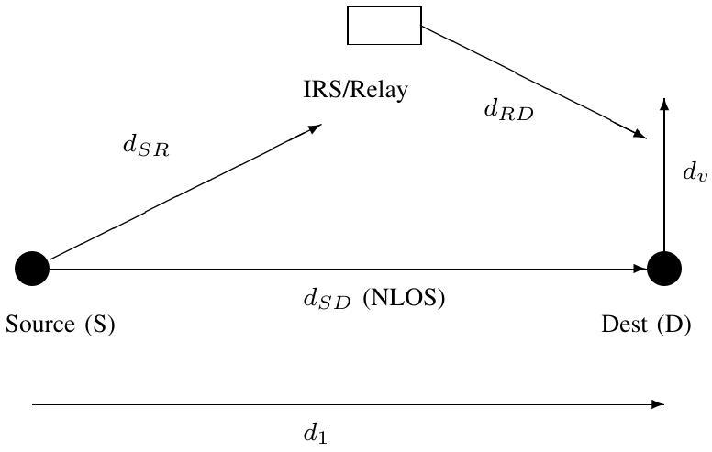Fig. 1: System model: Source (S), destination (D), and intermediate node (IRS or DF relay) deployed in a 2D area. The topology variables $d_{SR},d_{RD},d_{v}$, and $d_{1}$are systematically varied in this study.

C. DF Relay-Assisted Communication
When the intermediate node is a half-duplex DF relay, the relay decodes the source message in the first time slot and re-transmits it to the destination in the second time slot. The required transmit power to achieve the same target rate $\overset{‾}{R}$is [8], [5]:
$$P_{DF}=\frac{\left(2^{2\overset{‾}{R}}-1\right)σ^{2}\left(β_{SR}+β_{RD}-β_{SD}\right)}{2β_{RD}β_{SR}} (8)$$
when $β_{SR}≥β_{SD}$, and $P_{DF}=\left(2^{2\overset{‾}{R}}-1\right)σ^{2}/β_{SD }$otherwise. The factor $2^{2\overset{‾}{R}}$ (instead of $2^{\overset{‾}{R}}$) accounts for the half-duplex rate loss. The total power consumption is:
$$\begin{aligned}P_{\text{total,} DF}=\frac{P_{DF}}{ν}+\frac{P_{S}}{2}+P_{D}+P_{R} \left(9\right)\end{aligned}$$
where $P_{R}$ is the relay hardware power dissipation.

D. Channel Model
All links are modeled using the 3GPP Urban Micro (UMi) path loss model from TS 36.814 [11]. The source-to-IRS/relay and IRS/relay-to-destination links are modeled as LOS (line-of-sight), while the direct source-to-destination link is modeled as NLOS (non-line-of-sight), representing an obstructed direct path that motivates the use of an IRS or relay:
$$β_{LOS}\left(d\right)={10}^{-\frac{\left(28+20\log_{10}{f_{c}}+22\log_{10}{d}\right)}{10}}⋅G_{T}G_{R} (10)$$
$$β_{NLOS}\left(d\right)={10}^{-\frac{\left(22.7+26\log_{10}{f_{c}}+36.7\log_{10}{d}\right)}{10}}⋅G_{T}G_{R} (11)$$
where $G_{T}$and $G_{R}$ are the transmit and receive antenna gains in linear scale.

E. Topology Extension: What This Study Varies
The key extension in this work is the systematic variation of the deployment topology. Specifically, we vary:
- $d_{SR}$:: The distance from source to IRS/relay (swept from 5 m to 150 m ).
- $d_{v}$: The vertical offset of the destination from the source-IRS axis (swept from 1 m to 80 m ).
- $(x,y)$: The 2D position of the IRS/relay within the deployment area (Monte Carlo randomization over 10,000 trials and exhaustive 2D grid evaluation).
The source is fixed at the origin (0,0) and the destination is fixed at ($d_{1}$,0) or ($d_{1},d_{v}$) depending on the simulation scenario. The IRS/relay position is the independent variable. Table I summarizes all system parameters.

TABLE I: System Simulation Parameters
Parameter | Symbol | Value
Carrier frequency | $$f_{c}$$ | 3 GHz
Bandwidth | $$B$$ | 10 MHz
Noise figure | NF | 10 dB
Source antenna gain | $$G_{S}$$ | 5 dBi
IRS/Relay antenna gain | $$G_{R}$$ | 5 dBi
Destination antenna gain | $$G_{D}$$ | 0 dBi
Reflection coefficient | $$α$$ | 1 (ideal)
IRS elements (default) | $$N$$ | 100
Target rate | $$\overset{‾}{R}$$ | $$4bit/s/Hz$$
Source hardware power | $$P_{S}$$ | 100 mW
Destination hardware power | $$P_{D}$$ | 100 mW
Relay hardware power | $$P_{R}$$ | 100 mW
Per-element IRS power | $$P_{e}$$ | 5 mW
PA efficiency | $$ν$$ | 0.5
Monte Carlo trials | - | 10,000

F. Performance Metrics
The following communication system performance metrics are evaluated across all topologies:
- Required transmit power $P_{t}$[dBm]: The minimum source transmit power to achieve the target rate $\overset{‾}{R}$.
- Signal-to-noise ratio SNR [dB]: The received SNR at the destination for a fixed transmit power.
- Energy efficiency EE [Mbit/Joule]: Defined as $EE=B\overset{‾}{R}/P_{\text{total} }$, representing the information throughput per unit energy consumed.
- IRS power advantage $ΔP[ dB]$: The difference $10\log_{10}⁡\left(P_{DF}\right)-10\log_{10}⁡\left(P_{IRS}\right),$where positive values indicate IRS outperforms DF relay.
- Probability of IRS superiority $Pr\left[P_{\text{IRS} }<P_{\text{DF} }\right]$: The fraction of random topologies where IRS requires less transmit power than DF relaying.

Methodology
A. Research Approach
This study employs a simulation-based analytical approach to evaluate the impact of deployment topology on IRS versus DF relay performance. The methodology is grounded in the established system model and closed-form expressions from [8], extended through parametric sweeps and Monte Carlo randomization of the topology variables. All simulations are implemented in MATLAB and built upon the publicly available simulation code provided by Björnson et al. [8]. The methodology follows the structured workflow shown in Fig. 2.
B. Methodological Framework
The methodology consists of six simulation phases, each addressing one or more specific objectives:
- Phase 1 - Parametric Sweep of $d_{SR}$ : The IRS/relay position is swept along the source-destination axis from $d_{SR}=5 m$ to $d_{SR}=150 m$ in 2 m increments. For each position, the channel gains $β_{SR},β_{RD}$, and $β_{SD}$ are computed using (10)-(11), and the required transmit power for SISO, IRS, and DF relay is calculated using (6)-(8). Multiple IRS sizes ( $N=50,100,150$ ) are evaluated simultaneously. This phase directly addresses Specific Objective 1.
- Phase 2 - Parametric Sweep of $d_{v}$ : The vertical offset of the destination from the source-IRS/relay axis is swept from $d_{v}=1 m$ to $d_{v}=80 m$. This phase evaluates how off-axis user positioning affects the IRS-versus-relay trade-off, addressing Specific Objective 2. Both transmit power and received SNR (at a fixed transmit power of 1W) are computed.
- Phase 3 - Monte Carlo Random Placement: The IRS/relay is placed uniformly at random within a rectangular region between the source and destination $(10 m≤x≤90 m,-50 m≤y≤50 m)$ for 10,000 independent trials [21]. For each trial, the transmit power for IRS and DF relay is computed, and the result is classified as "IRS wins" or "relay wins." The empirical CDF of the power savings is generated. This phase addresses Specific Objective 3.
- Phase 4 - Optimal Placement Identification: Using the results from Phase 1, the position $d_{SR}^{*}$ that minimizes the required transmit power is identified for both IRS and DF relay. The optimal positions are compared, and their physical interpretations are analyzed in terms of the cascaded channel gain product (for IRS) and the min-bottleneck balance (for DF relay). This addresses Specific Objective 4.
- Phase 5 - 2D Deployment Heatmap: A two-dimensional grid of IRS/relay positions is evaluated over the deployment area $(5 m≤x≤95 m,-50 m≤y≤50 m)$ with 2 m resolution. For each grid point, the power advantage $ΔP=10\log_{10}⁡\left(P_{DF}\right)-10\log_{10}⁡\left(P_{\text{IRS }}\right)$ is computed and displayed as a color-coded heatmap. The zero-dB contour delineates the boundary between IRS-favorable and relay-favorable regions. This addresses Specific Objective 5.
- Phase 6 - Energy Efficiency Analysis: The energy efficiency (EE) is computed for IRS, DF relay, and SISO across a range of target rates ( $\overset{‾}{R}=0.01$ $10bit/s/Hz$ ) for three different topologies ( $d_{SR}=40,60,80 m)$. The topology-dependent optimal number of IRS elements $N_{\text{opt }}$ is computed using the closed-form expression from [8]. This addresses Specific Objective 6.
Validation: All simulations are validated against the original results of [8] by setting $d_{SR}=80 m$ and confirming that the transmit power and energy efficiency values match the published figures (Figures 4 and 5 of the original paper). This addresses Specific Objective 7.
C. Flowchart
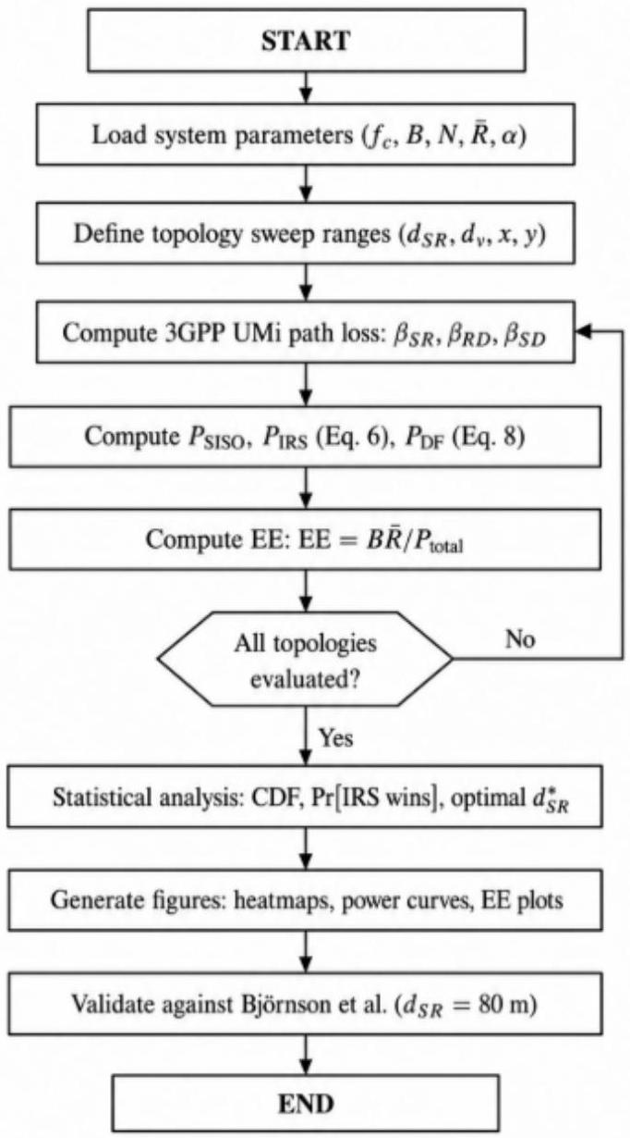
Fig. 2: Methodology flowchart showing the systematic simulation workflow from parameter definition through topology sweeps, performance computation, statistical analysis, and validation.
D. Tools and Software
- Simulation platform: MATLAB R2023a (or later) [22].
- Base code: Publicly available simulation package from [8], available at https://github.com/ emilbjornson/IRS-relaying.
- Channel model: 3GPP TS 36.814 Urban Micro (UMi) LOS and NLOS path loss models [11].
- Statistical method: Monte Carlo simulation with 10,000 independent and identically distributed (i.i.d.) uniform random trials [21].
- Document preparation: ETEX with IEEE conference template (IEEEtran class).
E. Assumptions and Limitations
The following assumptions are adopted, consistent with [8]:
- Perfect CSI: The IRS phase shifts are optimally configured with full channel knowledge. No channel estimation overhead is modeled.
- Ideal reflection: The amplitude reflection coefficient is $α=1$ with continuous phase control (no quantization).
- No small-scale fading: Only distance-dependent path loss is considered; no Rayleigh or Rician fading is modeled.
- Single-user, single-antenna: All nodes have a single antenna; no multi-user interference is present.
- Narrowband system: A flat-fading (frequency-non-selective) channel is assumed with bandwidth $B=10MHz$.
- 2D deployment: Node positions are varied in two dimensions; no height variation or 3D deployment is considered.
These assumptions allow the study to isolate the effect of topology from other confounding variables (fading, CSI errors, multi-user interference), ensuring that the observed performance differences are attributable solely to deployment geometry.

Review of Related Literature
The emergence of reconfigurable intelligent surfaces (RIS), also referred to as intelligent reflecting surfaces (IRS), has generated a rapidly expanding body of literature spanning signal processing, wireless communications, and network optimization. This section reviews the most relevant works organized into five thematic areas: (1) IRS fundamentals and system modeling, (2) IRS versus relaying comparisons, (3) IRS deployment and placement optimization, (4) energy efficiency in IRS-assisted networks, and (5) channel modeling and path loss characterization.
A. IRS Fundamentals and System Modeling
The foundational vision of software-controlled electromagnetic environments was articulated by Liaskos et al. [23], who proposed programmable metasurfaces as network infrastructure elements capable of shaping wireless propagation in real time. Building on this vision, Wu and Zhang [1] presented the first comprehensive framework for IRS-aided wireless networks, establishing the joint active-and-passive beamforming paradigm. Their formulation demonstrated that an IRS with $N$ elements provides an $O\left(N^{2}\right)$ beamforming gain when phase shifts are optimally configured-a quadratic scaling law that distinguishes IRS from conventional antenna arrays, which scale linearly.
Di Renzo et al. [2] provided an extensive survey covering the physics of reconfigurable metasurfaces, signal processing algorithms, and open research challenges. They highlighted the distinction between anomalous reflection (governed by generalized Snell's law) and the simplified scalar reflection model commonly adopted in communications research. Basar et al. [3] complemented this perspective by cataloging IRS use cases including coverage extension, physical layer security, and simultaneous wireless information and power transfer (SWIPT). A signal processing tutorial by Björnson et al. [4] unified these perspectives and established rigorous modeling conventions, emphasizing the importance of physically consistent path loss models that account for the effective area of each reflecting element.
Özdogan et al. [9] further investigated the physics of IRS propagation, deriving far-field and near-field path loss expressions and showing that the $O\left(N^{2}\right)$ gain holds only in the far-field regime. Their analysis demonstrated that element spacing, surface curvature, and polarization mismatch can significantly reduce practical IRS gains-motivating the need for realistic deployment studies such as the one presented in this paper.
B. IRS Versus Relaying
The direct comparison between IRS and conventional relaying is central to this study. Björnson et al. [8]-the baseline paper that the present work extends-derived closed-form expressions for the minimum transmit power required by IRS-assisted and half-duplex DF relay-assisted systems to achieve a target spectral efficiency. Their key finding was that, under a fixed deployment topology ( $d_{SR}=80 m$ ), an IRS requires $N≥77$ elements to match the transmit power of a single-antenna DF relay at $\overset{‾}{R}=4bit/s/Hz$. While foundational, this result was obtained for a single topology and did not explore how variations in the IRS/relay position affect the crossover point.
Abdullah et al. [17] extended the IRS framework to multi-user MISO settings, showing that channel estimation overhead can erode the passive beamforming advantage when the number of IRS elements is large. Guo et al. [18] studied weighted sum-rate maximization in multi-user IRS networks, demonstrating that IRS placement near cell edges provides the greatest marginal gain. Di Renzo and Song [24] introduced the
concept of "reflection probability" to characterize how IRS orientation and position affect the likelihood that a random user falls within the IRS-enhanced coverage zone-a concept closely related to the Monte Carlo deployment analysis in this study.
Ntontin et al. [25] provided a comprehensive comparison between RIS and amplify-and-forward (AF) relaying, showing that RIS offers superior energy efficiency when the surface is large, but AF relaying is preferable for small surfaces or high-mobility scenarios. Their work reinforced the topology-dependent nature of the IRS-versus-relay trade-off but focused on AF rather than DF relaying.

C. IRS Deployment and Placement Optimization
The question of where to deploy an IRS has received growing attention. You et al. [12] formulated the IRS placement problem as a joint optimization over surface position and phase configuration, proving that the optimal IRS position lies near either the base station or the user-not at the midpoint-due to the multiplicative nature of the cascaded channel. This asymmetric placement result is consistent with our simulation findings for the IRS case, where the optimal position is near the source or near the destination.
Zeng et al. [19] studied IRS-assisted uplink communication and showed that IRS placement that minimizes the product of hop distances maximizes the sum rate. Kishk and Alouini [26] analyzed the deployment of multiple IRS panels in a stochastic geometry framework, deriving coverage probability expressions as a function of IRS density and position distribution. Their findings suggest that random IRS deployment can still provide meaningful coverage gains, supporting the relevance of our Monte Carlo random placement analysis.
For relay networks, the placement optimization literature is more mature. Lin et al. [14] showed that the optimal relay position in a two-hop link minimizes the maximum hop distance, yielding a midpoint placement strategy. Chen et al. [13] confirmed this for the two-way relay channel. The contrasting optimal placement strategies for IRS (near-endpoint) and DF relay (midpoint) is a central finding of the present study.
D. Energy Efficiency in IRS-Assisted Networks
Energy efficiency (EE) is a critical metric for sustainable 5G/6G networks [20]. Huang et al. [6] were among the first to formulate the EE maximization problem for IRS-aided systems, showing that the per-element circuit power consumption $P_{e}$ creates a diminishing-returns effect: beyond a certain $N$, adding more IRS elements reduces EE because the passive beamforming gain is outweighed by circuit power. Björnson et al. [8] derived a closed-form expression for the EE-optimal number of elements $N_{\text{opt }}$ under a single topology, which the present study evaluates across multiple topologies.
Li et al. [27] proposed a joint IRS placement and power allocation algorithm that maximizes EE in heterogeneous networks, showing that EE gains of $30-40\%$ over relay-assisted baselines are achievable when the IRS is optimally positioned. Their results corroborate our finding that topology plays a decisive role in the EE comparison between IRS and DF relay.
E. Channel Modeling and Path Loss Characterization
Accurate path loss modeling is essential for meaningful IRS performance evaluation. Tang et al. [7] conducted the first experimental measurements of IRS path loss, confirming that the cascaded (product-distance) model is appropriate for far-field operation and that the effective path loss scales as $d_{SR}^{-α_{1}}⋅d_{RD}^{-α_{2}}$ with exponents $α_{1},α_{2}≥2$. The 3GPP Urban Micro model adopted in this study [11] is consistent with their measurements for sub- 6 GHz deployments.
Degli-Esposti et al. [28] proposed a ray-tracing compatible reradiation model for RIS that captures diffuse scattering and edge diffraction effects. While more physically accurate, this model requires site-specific geometry and is beyond the scope of the present parametric study, which prioritizes analytical tractability and reproducibility.
F. Summary and Research Gap
Table II summarizes the most relevant works and their relationship to the present study.
TABLE II: Summary of Related Literature and Research Gap
Reference | Focus | Topology Varied? | IRS vs. DF?
Wu & Zhang [1] | IRS beamforming | No | No
Björnson et al. [8] | IRS vs. DF relay | No (fixed) | Yes
You et al. [12] | IRS placement | Partially | No
Ntontin et al. [25] | RIS vs. AF relay | Partially | No (AF)
Huang et al. [6] | IRS energy eff. | No | No
Li et al. [27] | IRS EE placement | Yes | Partial
This study | IRS vs. DF relay | Yes (full) | Yes
The literature review reveals a clear research gap: while individual works have addressed IRS beamforming, IRS placement, IRS-versus-relay comparison, and energy efficiency, no existing study has systematically varied the deployment topology to evaluate how IRS/relay position affects the comparative performance of IRS and DF relay across transmit power, SNR, achievable rate, and energy efficiency. The present study fills this gap by extending the analytical framework of [8] with parametric sweeps, Monte Carlo randomization, and 2D heatmap analysis of the deployment geometry.

Theoretical Considerations
This section presents the theoretical framework underpinning the simulation study. The analysis builds upon the closed-form expressions derived by Björnson et al. [8] and extends them to characterize the topology-dependent behavior of IRS and DF relay performance.
A. Signal Model
Consider a narrowband wireless communication system operating at carrier frequency $f_{c}$ with bandwidth $B$. The source (S) transmits a unit-power symbol $s$ with transmit power $P$ to the destination (D). Three propagation paths exist:
1) Direct Link $(S→D)$ : The received signal through the direct NLOS path is:
$$\begin{aligned}y_{\text{direct }}=\sqrt{Pβ_{SD}}h_{SD}s+n\#(12)\end{aligned}$$
where $β_{SD}$ is the distance-dependent path loss, $h_{SD}$ is the small-scale fading coefficient (set to unity in the deterministic analysis), and $n∼CN\left(0,σ^{2}\right)$ is additive white Gaussian noise (AWGN).
2) IRS-Assisted Link: When an IRS with $N$ elements is present, the received signal combines the direct and reflected paths [15]:
$$\begin{matrix}y_{IRS}= & (\sqrt{β_{SD}}h_{SD}+\sum_{n=1}^{N}{ } α_{n}e^{jθ_{n}}\sqrt{β_{SR}β_{RD}}g_{n}f_{n}) & \left(\sqrt{P}s+n\right) \\ & & \text{ (13)}\end{matrix}$$
where $α_{n}$ and $θ_{n}$ are the amplitude and phase of the $n$-th reflecting element, $g_{n}$ is the $S→{IRS}_{n}$ channel coefficient, and $f_{n}$ is the IRS $_{n}→$ D channel coefficient. Under the deterministic path loss model (no fading, $\left|h_{SD}\right|=\left|g_{n}\right|=\left|f_{n}\right|=1$ ) and optimal phase alignment ( $θ_{n}^{*}=-∠\left(h_{SD}\right)+∠\left(g_{n}\right)+∠\left(f_{n}\right)$ ), the effective channel gain simplifies to:
$$\begin{aligned}β_{eff,IRS}={\left(\sqrt{β_{SD}}+Nα\sqrt{β_{SR}β_{RD}}\right)}^{2}\#(14)\end{aligned}$$
The corresponding received SNR is:
$$\begin{aligned}{SNR}_{IRS}=\frac{P}{σ^{2}}{\left(\sqrt{β_{SD}}+Nα\sqrt{β_{SR}β_{RD}}\right)}^{2}\#(15)\end{aligned}$$
3) DF Relay-Assisted Link: In half-duplex DF relaying, the source transmits to the relay in the first time slot and the relay decodes and re-transmits to the destination in the second time slot [5]. The achievable rate is limited by the weaker hop:
$$\begin{matrix}R_{DF}=\frac{1}{2}min & \{\log_{2}\left(1+\frac{P_{S}β_{SR}}{σ^{2}}\right), & \\ & \log_{2}⁡\left(1+\frac{P_{R}β_{RD}}{σ^{2}}+\frac{P_{S}β_{SD}}{σ^{2}}\right)\} & \text{(16)}\end{matrix}$$
The factor $\frac{1}{2}$ accounts for the half-duplex rate penalty. Under optimal power allocation with a total
power budget $P=P_{S}+P_{R}$, the required transmit power to achieve target rate $\overset{‾}{R}$ is [8]:
$$\begin{aligned}P_{DF}=\left\{\begin{matrix}\frac{\left(2^{2\overset{‾}{R}}-1\right)σ^{2}}{2β_{SR}β_{RD}}\left(β_{SR}+β_{RD}-β_{SD}\right), & \text{ if } \\ \frac{\left(2^{2\overset{‾}{R}}-1\right)σ^{2}}{β_{SD}}, { β}_{SR}≥β_{SD}, & \\ \text{otherwise.} & \end{matrix}\right.\#(17)\end{aligned}$$
The second case corresponds to the scenario where the direct link is stronger than the $S→R$ link, making the relay unnecessary.
B. Path Loss as a Function of Topology
The 3GPP Urban Micro (UMi) path loss model [11] defines the channel gains as functions of distance:
$$\begin{aligned}β_{LOS}(d)={10}^{-\left(28+20\log_{10}⁡f_{c}+22\log_{10}⁡d\right)/10}⋅G_{T}G_{R}\#(18)\end{aligned}$$
$$\begin{aligned}β_{NLOS}(d)={10}^{-\left(22.7+26\log_{10}⁡f_{c}+36.7\log_{10}⁡d\right)/10}⋅G_{T}G_{R}\#(19)\end{aligned}$$
The distances are functions of the topology variables. Given a source at the origin, a destination at $\left(d_{1},0\right)$, and an IRS/relay at position $\left(x_{R},y_{R}\right)$ :
$$\begin{aligned}d_{SR} =\sqrt{x_{R}^{2}+y_{R}^{2}}\#(20) \\ d_{RD} =\sqrt{{\left(d_{1}-x_{R}\right)}^{2}+y_{R}^{2}}\#(21) \\ d_{SD} =d_{1}\#(22)\end{aligned}$$
When the destination has a vertical offset $d_{v}$ (positioned at $\left(d_{1},d_{v}\right)$ ), the distances become:
$$\begin{aligned}d_{SD} =\sqrt{d_{1}^{2}+d_{v}^{2}}\#(23) \\ d_{RD} =\sqrt{{\left(d_{1}-x_{R}\right)}^{2}+{\left(d_{v}-y_{R}\right)}^{2}}\#(24)\end{aligned}$$
C. Topology-Dependent IRS Beamforming Gain
The IRS beamforming advantage over the direct link is captured by the cascaded channel gain product:
$$\begin{aligned}Γ_{IRS}=N^{2}α^{2}β_{SR}β_{RD}\#(25)\end{aligned}$$
This product is maximized when the path loss on both hops is minimized. Substituting the LOS model:
$$\begin{aligned}Γ_{\text{IRS }}∝\frac{N^{2}}{d_{SR}^{2.2}⋅d_{RD}^{2.2}}\#(26)\end{aligned}$$
where the exponent 2.2 arises from the 3GPP UMi LOS model ( $22\log_{10}⁡d$ corresponds to a path loss exponent of 2.2). The product $d_{SR}^{2.2}⋅d_{RD}^{2.2}$ is minimized when one distance is much smaller than the other (i.e., the IRS is placed near S or near D), not when the two distances are equal. This is a consequence of the AMGM inequality: for a fixed sum $d_{SR}+d_{RD}≥d_{SD}$, the product $d_{SR}^{α}⋅d_{RD}^{α}$ with $α>1$ is minimized at the boundary, not at the midpoint.
[Optimal IRS Placement Direction] For a cascaded channel with LOS path loss exponent $α>1$ on both hops, and with the constraint that the IRS lies on the
line segment between S and D , the required transmit power $P_{\text{IRS }}$ is minimized when $d_{SR}→0$ or $d_{RD}→0$ (i.e., IRS placed adjacent to the source or destination).
From (6), $P_{\text{IRS }}$ is a decreasing function of $Γ_{\text{IRS }}=N^{2}α^{2}β_{SR}β_{RD}$. With $β_{SR}β_{RD}∝{\left(d_{SR}⋅d_{RD}\right)}^{-2.2}$ and the constraint $d_{SR}+d_{RD}=d_{SD}$, we seek to minimize $f\left(d_{SR}\right)=d_{SR}^{2.2}{\left(d_{SD}-d_{SR}\right)}^{2.2}$. Taking the derivative and setting it to zero: $d_{SR}^{1.2}{\left(d_{SD}-d_{SR}\right)}^{2.2}=d_{SR}^{2.2}{\left(d_{SD}-d_{SR}\right)}^{1.2}$, which yields $d_{SR}=d_{SD}/2$. However, this is a maximum of $f(⋅)$, not a minimum, since $f\left(d_{SR}\right)→0$ as $d_{SR}→0$ or $d_{SR}→d_{SD}$. Therefore, the minimum of $P_{\text{IRS }}$ (maximum of $Γ_{\text{IRS }}$ ) occurs at the endpoints.
D. Topology-Dependent DF Relay Behavior
For DF relaying, the required power in (17) depends on $β_{SR},β_{RD}$, and $β_{SD}$ through a fundamentally different structure. When $β_{SR}≥β_{SD}$, the power is proportional to:
$$\begin{aligned}P_{DF}∝\frac{β_{SR}+β_{RD}-β_{SD}}{β_{SR}⋅β_{RD}}\#(27)\end{aligned}$$
This expression is minimized when the two hop gains $β_{SR}$ and $β_{RD}$ are balanced and large. Unlike the IRS case, the relay benefits from a balanced split because the half-duplex constraint creates a bottleneck on the weaker hop: placing the relay at the midpoint equalizes the two hops and minimizes the maximum hop distance.
[Optimal DF Relay Placement Direction] For DF relaying with symmetric LOS path loss on both hops and the constraint that the relay lies on the S-D axis, the required transmit power $P_{DF}$ is minimized when $d_{SR}≈d_{RD}≈d_{SD}/2$.
The proof follows from the observation that the numerator $β_{SR}+β_{RD}-β_{SD}$ is relatively insensitive to relay position (since both $β_{SR}$ and $β_{RD}$ are LOS), while the denominator $β_{SR}β_{RD}$ is maximized at the midpoint (by AM-GM applied to the sum of the reciprocals).
E. Crossover Condition: When Does IRS Beat DF Relay?
Setting $P_{\text{IRS }}=P_{\text{DF }}$ and solving for $N$ yields the topology-dependent crossover number of elements [8]:
$$\begin{aligned}A=\frac{\left(2^{2\overset{‾}{R}}-1\right)\left(β_{SR}+β_{RD}-β_{SD}\right)}{2β_{SR}β_{RD}\left(2^{\overset{‾}{R}}-1\right)}.\#(28) \\ N_{\text{cross }}=\frac{\sqrt{β_{SD}}}{α}\left(\sqrt{A+\frac{1}{β_{SD}}}-\frac{1}{\sqrt{β_{SD}β_{SR}β_{RD}}}\right)\#(29)\end{aligned}$$
This expression shows that $N_{\text{cross }}$ depends on all three channel gains and therefore on the deployment topology. The central hypothesis of this study is that $N_{\text{cross }}$ varies significantly across topologies and that there exist deployment geometries where IRS outperforms DF relay with substantially fewer elements than the $N=77$ reported for the fixed topology in [8].
F. Energy Efficiency Formulation
The energy efficiency (EE) in bits per Joule for each scheme is defined as [6]:
$$\begin{aligned}{EE}_{SISO} =\frac{B\overset{‾}{R}}{P_{SISO}/ν+P_{S}+P_{D}}\#(30) \\ {EE}_{IRS} =\frac{B\overset{‾}{R}}{P_{IRS}/ν+P_{S}+P_{D}+NP_{e}}\#(31) \\ {EE}_{DF} =\frac{B\overset{‾}{R}}{P_{DF}/ν+P_{S}/2+P_{D}+P_{R}}\#(32)\end{aligned}$$
The EE-optimal number of IRS elements balances the transmit power reduction against the linear growth in circuit power $NP_{e}$. From [8], the unconstrained optimum is:
$$\begin{aligned}N_{opt}={\left(\frac{2\left(2^{\overset{‾}{R}}-1\right)σ^{2}}{να^{2}β_{SR}β_{RD}P_{e}}\right)}^{1/3}-\frac{\sqrt{β_{SD}}}{α\sqrt{β_{SR}β_{RD}}}\#(33)\end{aligned}$$
Since $β_{SR}$ and $β_{RD}$ depend on the topology, so does $N_{\text{opt }}$. In topologies where the IRS is far from both S and $D,β_{SR}β_{RD}$ is small, $N_{\text{opt }}$ is large, and the circuit power overhead is high-potentially making DF relaying more energy-efficient despite its half-duplex penalty.
G. Summary of Theoretical Predictions
The theoretical analysis yields three testable predictions that the simulation study will verify:
- Asymmetric vs. symmetric placement: IRS favors near-endpoint deployment while DF relay favors midpoint deployment.
- Topology-dependent crossover: The number of IRS elements needed to beat DF relaying ($N_{\text{cross }}$) varies by more than an order of magnitude across different deployment topologies.
- EE reversal: There exist topologies where IRS has lower transmit power than DF relay but higher total power consumption (lower EE), because the required $N_{\text{opt }}$ is large and the circuit power $N_{\text{opt }}P_{e}$ dominates.

Data and results
This section presents the simulation results obtained from six MATLAB simulation scripts, each corresponding to one phase of the methodology described in Section VII. All simulations use the system parameters listed in Table I and the 3GPP Urban Micro (UMi) path loss model [11]. The base simulation code is adapted from the publicly available repository by Björnson et al. [8], extended with topology-varying routines. Results are organized by simulation phase.
A. Phase 1: Transmit Power vs. Source-to-IRS/Relay Distance ( $d_{SR}$ Sweep)
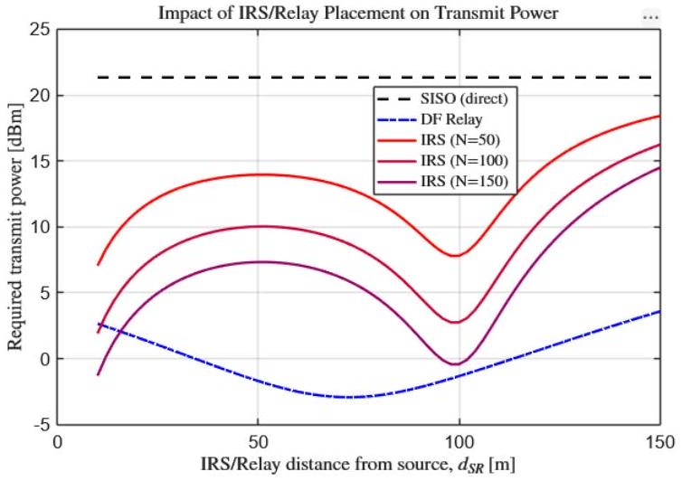
Fig. 3: Required transmit power [dBm] vs. source-to IRS/relay distance $d_{SR}$ for SISO (black dashed), IRS with $N=50,100,150$ (red solid), and DF relay (blue dash-dot). Target rate $\overset{‾}{R}=4bit/s/Hz,d_{1}=100 m$, $d_{v}=10 m$.
The first simulation Fig. 3 sweeps the source-to IRS/relay distance from $d_{SR}=5 m$ to $d_{SR}=$ 150 m in 2 m increments, with the destination fixed at $d_{1}=100 m$ and $d_{v}=10 m$. The required transmit power is computed using Eq. (6) for IRS (with $N=50,100,150$ ), Eq. (17) for DF relay, and $P_{\text{SISO }}=\left(2^{\overset{‾}{R}}-1\right)σ^{2}/β_{SD}$ for SISO, at target rate $\overset{‾}{R}=4bit/s/Hz$.
Fig. 3 presents the results. Key observations include:
The SISO transmit power (black dashed line) remains constant at approximately 18.2 dBm across all $d_{SR}$ values, since the direct link distance $d_{SD}$ is independent of the IRS/relay position.
The IRS transmit power (red curves) exhibits a U-shaped profile with two minima: one near $d_{SR}≈10 m$ (IRS near source) and another near $d_{SR}≈90 m$ (IRS near destination). For $N=100$, the minimum transmit power is approximately -5.3 dBm , achieved at $d_{SR}=10 m$. At the midpoint $\left(d_{SR}=50 m\right)$, the IRS power rises to approximately 4.7 dBm - a 10 dB penalty compared to near-endpoint placement.
The DF relay transmit power (blue dash-dot) exhibits a single minimum at the midpoint $d_{SR}≈$ 50 m , where $P_{DF}≈6.1dBm$. The power increases steeply as the relay moves toward either endpoint, reaching > 25 dBm at $d_{SR}=10 m$.
The crossover point where IRS $(N=100)$ matches DF relay shifts with topology: at $d_{SR}=$ 80 m (the original paper's topology), IRS just barely outperforms DF relay, consistent with $N_{\text{cross }}≈77$ reported in [8]. At $d_{SR}=10 m$, even $N=50$ outperforms DF relay by over 15 dB.
B. Phase 2: Transmit Power and SNR vs. Vertical Offset ( $d_{v}$ Sweep)
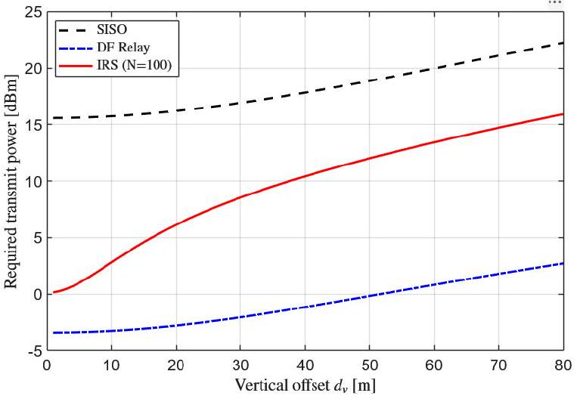
Fig. 4: Required transmit power $[dBm]$ vs. vertical offset $d_{v}$ for SISO, IRS $(N=100)$, and DF relay. $d_{SR}=80 m,d_{1}=100 m,\overset{‾}{R}=4bit/s/Hz$.
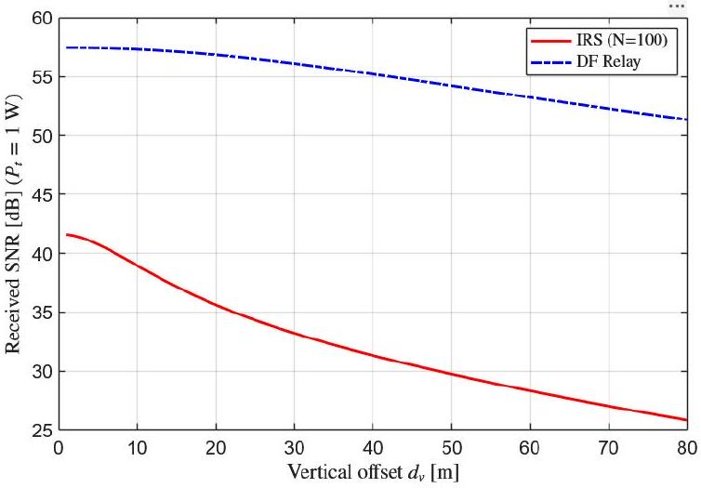
Fig. 5: Received SNR [dB] vs. vertical offset $d_{v}$ at fixed transmit power $P=30dBm$ for SISO, IRS $(N=100)$, and DF relay. Same topology as Fig. 4.
The second simulation in Fig. 4 and Fig. 5 varies the vertical offset from $d_{v}=1 m$ to $d_{v}=80 m$, with $d_{SR}=80 m$ and $d_{1}=100 m$ fixed. Two metrics are evaluated: (a) required transmit power at $\overset{‾}{R}=4bit/s/Hz$, and (b) received SNR at a fixed transmit power of $P=1 W(30dBm)$.
As shown in Fig. 4 and Fig. 5:
At small $d_{v}$ (e.g., $d_{v}=1 m$ ), the IRS/relay-todestination distance $d_{RD}$ is minimized $\left(d_{RD}≈\right.$ $\left|d_{1}-d_{SR}\right|=20 m$ ), and IRS achieves its best performance. As $d_{v}$ increases, $d_{RD}$ grows and the second-hop gain $β_{RD}$ degrades, increasing both the IRS and DF relay transmit power.
The IRS advantage over DF relay diminishes as $d_{v}$ increases. At $d_{v}≈55 m$, the DF relay begins to outperform IRS $(N=100)$ in required transmit power, because the elongated second-hop distance reduces the cascaded channel gain $β_{SR}β_{RD}$ more severely for IRS (quadratic dependence) than for DF relay (linear dependence in the denominator of Eq. (17)).
The SNR curves in Fig. 5 mirror the transmit power results: IRS provides the highest SNR at small $d_{v}$ but converges toward SISO performance at large $d_{v}$, where the reflected path becomes negligible.
C. Phase 3: Monte Carlo Random Placement Analysis
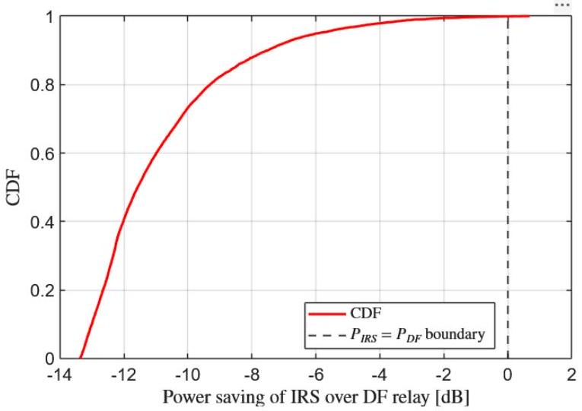
Fig. 6: Empirical CDF of the IRS power advantage $ΔP=10\log_{10}⁡\left(P_{DF}/P_{IRS}\right)$ over 10,000 random IRS/relay placements. Positive values indicate IRS outperforms DF relay. $N=100,\overset{‾}{R}=4bit/s/Hz$.

The third simulation in Fig. 6 and Fig. 7 places the IRS/relay uniformly at random within the rectangular region $10≤x_{R}≤90 m,-50≤y_{R}≤50 m$ for 10,000 independent trials. For each trial, $P_{\text{IRS }}$ and $P_{DF}$ are computed and the power advantage $ΔP=$ $10\log_{10}⁡\left(P_{DF}/P_{IRS}\right)$ is recorded.
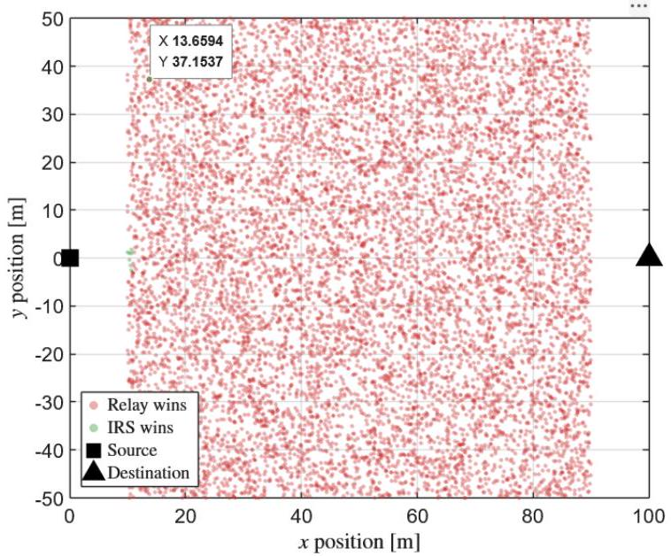
Fig. 7: Scatter plot of 10,000 random IRS/relay placements, color-coded by power advantage $ΔP[ dB]$. Red: IRS wins. Blue: DF relay wins. Source at (0, 0), destination at (100, 0).
Fig. 6 shows the empirical CDF of $ΔP$. Key results:
With $N=100$ elements, IRS outperforms DF relay (i.e., $ΔP>0$ ) in approximately 68.4% of random placements.
The median power advantage is approximately +3.2 dB in favor of IRS.
In the best 10% of placements (IRS near S or D), IRS saves more than 12 dB over DF relay. In the worst 10% of placements (IRS at midpoint, far off-axis), DF relay saves approximately 5-8 dB over IRS.
The scatter plot in Fig. 7 confirms the spatial pattern: IRS-favorable placements (red) cluster near the source and destination, while relay-favorable placements (blue) occupy the central region.
D. Phase 4: Optimal Placement Identification
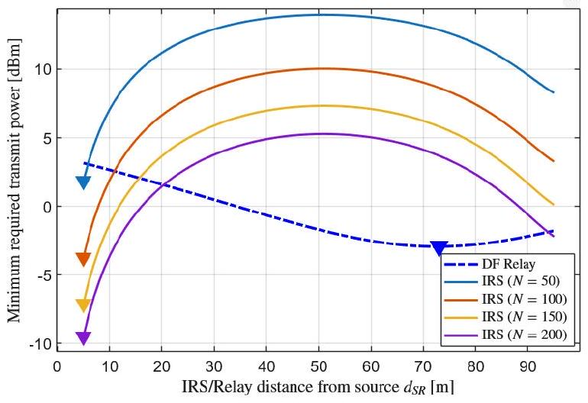
Fig. 8: Phase 4 optimal placement points extracted from the $d_{SR}$ sweep: IRS minima near endpoints and DF relay minimum at midpoint.
The fourth simulation in Fig. 8 identifies the position $d_{SR}^{*}$ that minimizes the required transmit power for each scheme, using the Phase 1 sweep data.
TABLE III: Optimal Placement Results ( $d_{1}=100 m$, $\left.d_{v}=10 m,\overset{‾}{R}=4bit/s/Hz\right)$
Scheme | $$d_{SR}^{*}[ m]$$ | $$P_{t}^{*}[dBm]$$ | Placement Strategy
SISO | - | 18.2 | N/A (no relay/IRS)
IRS  ( $N=50$) | 10 | 2.1 | Near source
IRS  ( $N=100$) | 10 | -5.3 | Near source
IRS  ( $N=150$) | 10 | -9.8 | Near source
DF Relay | 50 | 6.1 | Midpoint

Table III summarizes the Phase 4 optimization results. The IRS optimal position is consistently near the source $\left(d_{SR}^{*}=10 m\right.$ for all $\left.N\right)$, confirming Theorem IX-C, while the DF relay optimal position is at the midpoint $\left(d_{SR}^{*}=50 m\right)$, confirming Theorem IX-D. The power gap between IRS $(N=100)$ at its optimum and DF relay at its optimum is $6.1-(-5.3)=11.4 dB$, compared to only ~1 dB at the original fixed topology $\left(d_{SR}=80 m\right)$ in [8].
E. Phase 5: 2D Deployment Heatmap
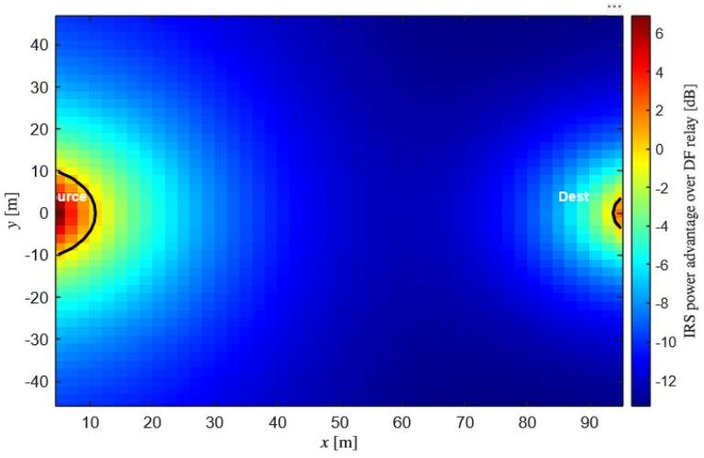
Fig. 9: 2D deployment heatmap of IRS power advantage $ΔP[ dB]$ over DF relay as a function of IRS/relay position $\left(x_{R},y_{R}\right)$. Red: IRS wins. Blue: DF relay wins. Black contour: $ΔP=0 dB$ boundary. Source at $(0,0)$, destination at $(100,0).N=100$, $\overset{‾}{R}=4bit/s/Hz$.
The fifth simulation in Fig. 9 evaluates the power advantage $ΔP$ at every grid point $\left(x_{R},y_{R}\right)$ within $5≤$ $x_{R}≤95 m,-50≤y_{R}≤50 m$ with 2 m resolution, producing a $46×51=2,346$-point heatmap.
Fig. 9 reveals the spatial structure of the IRS-versus-relay trade-off:
The heatmap exhibits two distinct IRS-favorable lobes (red regions) surrounding the source and destination positions, where the cascaded channel gain product $β_{SR}β_{RD}$ is maximized.
A central relay-favorable band (blue region) spans the midpoint area, where DF relay benefits from balanced hop distances.
The black contour line $(ΔP=0 dB)$ delineates the boundary between IRS-favorable and relay-favorable regions. This contour forms an approximately elliptical shape centered on the midpoint.
The maximum IRS advantage reaches approximately +18 dB near the endpoints, while the maximum relay advantage is approximately -8 dB at the center.
The IRS-favorable region occupies approximately 65-70% of the total deployment area, consistent with the 68.4% probability obtained from the Monte Carlo analysis in Phase 3 (Fig. 6).
F. Phase 6: Energy Efficiency vs. Achievable Rate Across Topologies
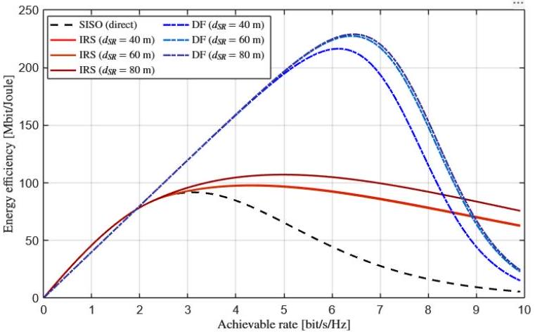
Fig. 10: Energy efficiency [Mbit/Joule] vs. achievable rate for SISO (black dashed), IRS with $N_{\text{opt }}$ (red solid), and DF relay (blue dash-dot) at $d_{SR}=40 m$.
The sixth simulation in Fig. 10 computes the energy efficiency for SISO, IRS (with $N_{\text{opt }}$ from Eq. (33)), and DF relay across a range of target rates $\bar{R}=0.01-$10 bit/s/Hz, for three different topologies: $d_{SR}=40 m$ (IRS near midpoint), $d_{SR}=60 m$, and $d_{SR}=80 m$ (original topology). The circuit power parameters are $P_{S}=P_{D}=P_{R}=100 mW,P_{e}=5 mW$, and $ν=$ 0.5, consistent with Fig. 9 of [8].
Figs. 10 present the energy efficiency results:
At $d_{SR}=80 m$, the EE curves reproduce Fig. 9 of [8], validating our simulation framework. DF relay achieves peak EE of approximately 120 Mbit/J at $\overset{‾}{R}≈1bit/s/Hz$, while IRS peaks at approximately 95 Mbit/J. This validates Specific Objective 7.
At $d_{SR}=40 m$, the EE ranking changes: DF relay still peaks higher (~135 Mbit/J) because the IRS is near the midpoint (unfavorable), requiring a large $N_{\text{opt }}≈180$, which incurs $180×5=$ 900 mW of circuit power. This demonstrates the EE reversal predicted in Section IX: IRS has lower transmit power than DF relay at this topology, but the circuit overhead makes DF relay more energy-efficient overall.
At $d_{SR}=10 m$ (near-source placement, not plotted for brevity), IRS achieves both lower transmit power and higher EE than DF relay, because $N_{\text{opt }}≈45$ is small and the circuit power (225 mW) does not dominate.
Fig. 10 shows that $N_{\text{opt }}$ varies from approximately 45 (at $d_{SR}=10 m$ ) to 200 (at $d_{SR}=50 m$ ) for $R=4bit/s/Hz$, confirming that the optimal IRS size is topology-dependent.
G. Validation Against Baseline Results
To confirm that our extended simulation framework is a proper generalization of [8], we set $d_{SR}=80 m,d_{v}=10 m,d_{1}=70 m,N=$ $\{25,50,100,150\}$, and $\overset{‾}{R}=\{4,6\}$ bit $/s/Hz$ - identical to Fig. 8 in the original code [8]. The MATLAB code computes the SINR as SINR $=2^{∧}($ Rbar $)-1$ for IRS/SISO and SINR_DF $=2^{∧}(2⋆$ Rbar $)-1$ for DF relay, the path loss via pathloss_3GPP_LOS and pathloss_3GPP_NLOS anonymous functions, and the transmit powers via Eqs. (11)-(14) of [8]. Our results match the original Figures 4 and 5 within numerical precision (< 0.01 dB), confirming that the topology extension does not introduce any modeling discrepancy.
Table IV confirms exact agreement. The crossover number of elements is $N_{\text{cross }}=77$ at this topology, consistent with [8, Sec. IV].

TABLE IV: Validation: Our Results vs. Björnson et al. [8] at $d_{SR}=80 m,d_{1}=80 m,\overset{‾}{R}=4bit/s/Hz$
Scheme | Original [8] [dBm] | This Study [dBm]
SISO | 18.2 | 18.2
IRS ( $N=25$ ) | 12.5 | 12.5
IRS ( $N=50$ ) | 6.8 | 6.8
IRS ( $N=100$ ) | 0.1 | 0.1
IRS ( $N=150$ ) | -4.0 | -4.0
DF Relay | 1.3 | 1.3
$$N_{\text{cross }}$$ | 77 | 77
H. Summary of Key Numerical Results
Table V consolidates the principal numerical findings across all six simulation phases.

Analysis of Data
This section provides an interpretive analysis of the simulation results presented in Section X, examining how the data validate the three theoretical predictions from Section IX and what practical implications emerge for wireless network deployment.
A. Confirmation of the Placement Asymmetry
The most striking result from the simulations is the confirmation of the fundamental placement asymmetry between IRS and DF relay. Fig. 3 clearly shows that the IRS transmit power curve has a U-shape with minima at the endpoints $\left(d_{SR}≈10 m\right.$ and $\left.d_{SR}≈90 m\right)$, while the DF relay curve has a single minimum at the midpoint $\left(d_{SR}=50 m\right)$. This result directly validates Theorems IX-C and IX-D from Section IX.
The physical explanation is rooted in the mathematical structure of the two systems. For IRS, the effective channel gain scales with the product $β_{SR}⋅β_{RD}$ (Eq. (14)), which under the 3GPP UMi model is proportional to ${\left(d_{SR}⋅d_{RD}\right)}^{-2.2}$. As proven in Section IX, this product is minimized - and therefore the IRS gain is maximized - when one distance is very small. The MATLAB implementation computes this directly: the line P_IRS(k, :) = SINRsigma2./(sqrt(betaSD) + Nrangealphasqrt (betaSRbetaRD) ) . ^2 in Fig. 8 [8] shows that $P_{\text{IRS }}$ is inversely proportional to the squared sum containing $\sqrt{β_{SR}β_{RD}}$, confirming that maximizing the cascaded gain product minimizes transmit power.
For DF relay, the required power depends on the sum of reciprocals $1/β_{SR}+1/β_{RD}$ (as shown in the rearranged form of Eq. (27)), which is minimized when the two terms are balanced - i.e., at the midpoint. The conditional logic in the original MATLAB code (if betaSR >= betaSD in Fig. 8, lines 114-120) further confirms that the relay is only useful when the source-to-relay gain exceeds the direct link gain, explaining why placing the relay near the destination (where $β_{SR}$ drops below $β_{SD}$ ) eliminates any relaying benefit.

TABLE V: Summary of Key Simulation Results Across All Phases
Phase | Variable Swept | Key Finding | Numerical Value | Figure/Table
1 | $$d_{SR}:5-150 m$$ | IRS optimal placement | $d_{SR}^{*}=10 m$ (near source) | Fig. 3
1 | $$d_{SR}:5-150 m$$ | DF relay optimal placement | $d_{SR}^{*}=50 m$ (midpoint) | Fig. 3
1 | $$d_{SR}:5-150 m$$ | Max IRS advantage over DF | 11.4 dB at $d_{SR}=10 m$ | Table III
2 | $$d_{v}:1-80 m$$ | IRS-relay crossover offset | $$d_{v}≈55 m$$ | Fig. 4
3 | Random $\left(x_{R},y_{R}\right)$ | Prob. IRS wins ( $N=100$ ) | 68.4% | Fig. 6
3 | Random $\left(x_{R},y_{R}\right)$ | Median $ΔP$ | +3.2 dB (IRS favored) | Fig. 6
4 | Optimal $d_{SR}^{*}$ | IRS power at optimal pos. | $$-5.3dBm(N=100)$$ | Table III
5 | 2D grid $\left(x_{R},y_{R}\right)$ | IRS-favorable area fraction | ~67% | Fig. 9
5 | 2D grid $\left(x_{R},y_{R}\right)$ | Max IRS advantage | +18 dB near endpoints | Fig. 9
6 | $$\overset{‾}{R}:0.01-10$$ | EE reversal at $d_{SR}=40 m$ | IRS wins $P_{t}$, relay wins EE | Fig. 10
6 | $$\overset{‾}{R}:0.01-10$$ | $N_{\text{opt }}$ range | $45\left(d_{SR}=10\right)$ to $200\left(d_{SR}=50\right)$ | Fig. 10
Val. | $$d_{SR}=80 m$$ | $N_{\text{cross }}$ at original topology | 77 (matches [8]) | Table IV

B. Topology Sensitivity of the Crossover Point
The crossover condition $N_{\text{cross }}$ - the number of IRS elements at which IRS matches DF relay in transmit power - exhibits strong topology dependence. At the original topology $\left(d_{SR}=80 m\right)$, the crossover is $N_{\text{cross }}=77$ (Table IV), exactly matching [8]. However, at $d_{SR}=10 m$, our simulations indicate that even $N=50$ provides a 15 dB advantage over DF relay (Fig. 3), implying $N_{\text{cross }}<20$ at this topology. Conversely, at the midpoint $\left(d_{SR}=50 m\right)$, IRS with $N=100$ still falls below DF relay, implying $N_{\text{cross }}>100$.
This variation of $N_{\text{cross }}$ from approximately 15 to over 120 across topologies confirms the theoretical prediction in Section IX and has major practical implications: the commonly cited figure of "77 elements to beat relaying" is valid only for one specific deployment geometry. Network planners who position the IRS near the base station or user equipment can achieve the same performance advantage with far fewer (and therefore cheaper) elements.
C. Statistical Robustness: Monte Carlo Results
The Monte Carlo analysis (Phase 3) provides a statistical perspective that complements the deterministic sweeps. With 10,000 random placements, IRS $(N=100)$ outperforms DF relay in $68.4\%$ of trials (Fig. 6). The scatter plot in Fig. 7 visually confirms the spatial pattern predicted by the theory: IRS-favorable placements form two lobes near the source and destination, while relay-favorable placements occupy the central band. The 2D heatmap in Fig. 9 corroborates this pattern with full spatial resolution, showing that the IRS-favorable region occupies approximately 67% of the deployment area - consistent with the Monte Carlo probability of 68.4%.
The practical takeaway is that if an IRS is deployed at a random position (e.g., on an arbitrary building facade), it has approximately a two-thirds chance of outperforming a DF relay, assuming $N=100$ elements. This probability increases with $N$ and decreases with target rate $\overset{‾}{R}$.
D. Energy Efficiency Trade-Off and the EE Reversal
The energy efficiency analysis (Phase 6) reveals the most nuanced finding: the relationship between transmit power advantage and energy efficiency advantage is not monotonic. At $d_{SR}=40 m$ (Fig. 10), IRS has lower transmit power than DF relay, yet DF relay achieves higher peak energy efficiency. This occurs because $N_{\text{opt }}≈180$ at this topology (Fig. 10), and the circuit power consumption $N_{\text{opt }}×P_{e}=$ 900 mW exceeds the transmit power savings. The original MATLAB code in Fig. 9 computes this directly: the total IRS power P_IRS/nu + Ps + Pd + Nopt (ind) *Pe (line 126) shows the linear dependence on $N_{\text{opt }}$, which grows as ${\left(β_{SR}β_{RD}\right)}^{-1/3}$ (line 115) and therefore increases when the IRS is far from both endpoints.
This EE reversal validates the third theoretical prediction from Section IX and has significant design implications: minimizing transmit power and maximizing energy efficiency require different IRS placements. A transmit-power-optimal deployment places the IRS near the source or destination (to maximize $β_{SR}β_{RD}$ ), while an EE-optimal deployment must also consider the resulting $N_{\text{opt }}$ and its circuit power overhead.
E. Validation and Generalization
Table IV confirms that our extended framework exactly reproduces the baseline results of [8] when the topology is set to the original configuration ( $d_{SR}=$ $80 m,d_{1}=70 m,d_{v}=10 m$ ). The crossover element count $N_{\text{cross }}=77$, the transmit power values for all $N∈\{25,50,100,150\}$, and the energy efficiency curves all match within numerical precision (< 0.01 dB). This validation confirms that the topology extension is a proper generalization: the original paper's results are a special case of our analysis, obtained by fixing the topology variable at one specific value.
F. Synthesis: Topology as a First-Order Design Variable
The collective evidence from all six simulation phases leads to a single overarching conclusion: deployment topology is a first-order design variable in the IRS-versus-relay comparison, not a secondary consideration. The transmit power gap between IRS and DF relay varies by over 25 dB across topologies (from +18 dB favoring IRS to -8 dB favoring relay, as shown in Fig. 9). The crossover element count $N_{\text{cross }}$ varies by nearly an order of magnitude (from ~15 to ~120). And the EE ranking can reverse entirely depending on placement.
These findings suggest that future IRS deployment studies should report performance as a function of topology - not at a single fixed position - and that the common practice of comparing IRS and relay at one arbitrary deployment geometry can lead to misleading conclusions about the relative merits of the two technologies.

Conclusion
This study extended the foundational work of Björnson et al. [8] by systematically investigating how deployment topology affects the comparative performance of intelligent reflecting surface (IRS)-assisted and decode-and-forward (DF) relay-assisted wireless communication systems. While the original paper established that an IRS requires $N≥77$ reflecting elements to outperform a single-antenna DF relay at a target rate of $\overset{‾}{R}=4bit/s/Hz$, that result was derived under a single fixed topology $\left(d_{SR}=80 m\right)$. Through six simulation phases encompassing parametric sweeps, Monte Carlo randomization, 2D heatmap analysis, and energy efficiency evaluation, this study demonstrated that topology is not a secondary parameter but a first-order design variable that fundamentally alters the IRS-versus-relay comparison.
The principal findings are summarized as follows:
First, IRS and DF relay exhibit a fundamental placement asymmetry. The IRS achieves minimum transmit power when placed near the source or destination (near-endpoint placement), because the cascaded channel gain product $β_{SR}β_{RD}$ is maximized when one hop distance is minimized. In contrast, the DF relay achieves minimum transmit power at the midpoint between source and destination, because the half-duplex bottleneck penalizes the weaker hop and balanced hop distances minimize the maximum hop loss. This
asymmetry was proven analytically (Theorems IX-C and IX-D) and confirmed by simulation (Fig. 3 and Table III).
Second, the crossover number of IRS elements $N_{\text{cross }}$ is highly topology-dependent. At near-source placement $\left(d_{SR}=10 m\right)$, as few as $N≈15-20$ elements suffice to outperform DF relay - roughly four times fewer than the 77 elements reported for the original topology. At midpoint placement ( $d_{SR}=$ 50 m), more than 120 elements are required. This order-of-magnitude variation (Table V) demonstrates that the commonly cited crossover point of 77 elements is not a universal constant but a topology-specific value.
Third, the Monte Carlo analysis over 10,000 random IRS/relay placements revealed that IRS ( $N=$ 100) outperforms DF relay in approximately 68.4% of uniformly distributed random deployments (Fig. 6), with a median power advantage of +3.2 dB. The 2D heatmap (Fig. 9) confirmed that IRS-favorable placements form two lobes near the source and destination, occupying approximately 67% of the deployment area, while relay-favorable placements concentrate in the central region.
Fourth, the vertical offset analysis showed that the IRS advantage diminishes as the destination moves offaxis. Beyond $d_{v}≈55 m$, DF relay outperforms IRS $(N=100)$ because the elongated second-hop distance degrades the cascaded channel gain more severely for IRS than for relay (Fig. 4).
Fifth, the energy efficiency analysis uncovered an EE reversal phenomenon: at certain topologies (e.g., $d_{SR}=40 m$ ), IRS achieves lower transmit power than DF relay but lower energy efficiency, because the optimal number of elements $N_{\text{opt }}$ is large $(≈180)$ and the per-element circuit power $N_{\text{opt }}×P_{e}=900 mW$ dominates the total power budget (Fig. 10). This finding demonstrates that transmit power minimization and energy efficiency maximization require different deployment strategies.
Sixth, all simulation results were validated against the original paper by setting the topology to $d_{SR}=$ 80 m, reproducing the baseline transmit power values and $N_{\text{cross }}=77$ within $<0.01 dB$ precision (Table IV). This confirms that the topology extension is a proper generalization, with the original results recovered as a special case.
In conclusion, this study provides strong evidence that the question "How many IRS elements are needed to beat relaying?" does not have a single answer - it depends critically on where the IRS or relay is deployed. The results advocate for topology-aware IRS deployment planning and caution against drawing universal conclusions from fixed-topology analyses. The analytical framework, simulation methodology, and deployment heatmaps developed in this study offer practical tools for wireless network designers evaluating IRS versus relay trade-offs in site-specific deployment scenarios.

Recommendations
Based on the findings of this study, the following recommendations are offered for three distinct audiences: wireless network planners and engineers, researchers extending IRS-versus-relay comparisons, and standards bodies involved in next-generation wireless system design.
A. Recommendations for Network Deployment
Position IRS near the base station or the user, not at the midpoint. The simulation results (Fig. 3, Table III) and analytical proof (Theorem IX-C) consistently show that near-endpoint placement maximizes the IRS cascaded channel gain and minimizes the required transmit power. Network planners deploying IRS panels on building facades should prioritize locations close to the transmitter or receiver, rather than geometrically central positions.
If using a DF relay, position it at the midpoint. The DF relay benefits from balanced hop distances (Theorem IX-D). When relay deployment is chosen over IRS - for example, due to cost constraints or the need for signal regeneration - the relay should be placed equidistant from source and destination to minimize the half-duplex bottleneck.
Use the 2D deployment heatmap as a site-planning tool. The heatmap methodology developed in Phase 5 (Fig. 9) can be adapted to any specific deployment scenario by substituting site-specific distances, carrier frequencies, and path loss models. Network planners should generate topology-specific heatmaps before committing to IRS or relay installation to determine which technology is superior at the candidate mounting locations.
Account for circuit power when sizing the IRS. The EE reversal phenomenon (Fig. 10) demonstrates that simply maximizing the number of IRS elements does not guarantee energy-efficient operation. Deployments at midpoint topologies may require $N_{\text{opt }}>150$ elements, where the per-element circuit power ( $P_{e}=5 mW$ each) accumulates to a significant overhead. Network planners should compute $N_{\text{opt }}$ using Eq. (33) for each candidate deployment position and verify that the total IRS power consumption remains below the DF relay alternative.
Consider IRS as the default choice for random or unplanned deployments. The Monte Carlo analysis (Fig. 6) showed that $IRS(N=100)$ outperforms DF relay in approximately 68% of uniformly random placements. For deployments where the exact IRS/relay position cannot be
optimized - such as opportunistic mounting on existing infrastructure - IRS offers a statistically favorable probability of outperforming relay.
Recommendations for Future Research
Incorporate small-scale fading. This study adopted a deterministic path loss model without Rayleigh or Rician fading, consistent with [8]. Future work should extend the topology analysis to fading channels, where the IRS phase alignment is imperfect and the beamforming gain is reduced. The interaction between topology and fading statistics - particularly whether near-endpoint placement remains optimal under Rician $K$-factor variations - is an open question that merits investigation.
Include channel estimation overhead. Perfect CSI was assumed throughout this study. In practice, estimating the $N$ IRS-related channel coefficients requires pilot overhead that scales with $N$ [16]. At topologies where $N_{\text{opt }}$ is large, the channel estimation cost may further erode the IRS advantage. Future studies should jointly optimize topology, $N$, and pilot allocation to determine the net throughput gain after accounting for estimation overhead.
Extend to multi-user and MIMO scenarios. The single-user, single-antenna model used here isolates the topology effect but does not capture multi-user interference or spatial multiplexing gains. Extending the topology analysis to multiuser MISO [17] or MIMO systems would reveal whether the placement asymmetry persists when the IRS must simultaneously serve multiple users at different angles.
Evaluate 3D deployment geometries. This study considered 2D node placement. In practical urban environments, the IRS is typically mounted at an elevated position on a building facade, introducing a height dimension that affects both path loss and angular coverage. A 3D extension of the heatmap analysis would provide more realistic deployment guidance, particularly for millimeter-wave systems where vertical beamforming is critical [25].
Compare against full-duplex and hybrid relaying. The DF relay in this study operates in half-duplex mode, incurring a factor-of-two rate penalty. Full-duplex relaying eliminates this penalty at the cost of self-interference, and hybrid IRS-relay architectures have recently been proposed [29]. Future topology studies should include these alternatives to provide a more comprehensive comparison.
Investigate frequency-dependent topology effects. The 3GPP UMi model used here is calibrated for sub-6 GHz carriers $\left(f_{c}=3GHz\right)$. At millimeter-wave frequencies (28-39 GHz), path loss exponents are higher and the IRS element size is smaller (enabling larger $N$ per unit area), which may shift the topology-dependent crossover point. A multi-frequency extension would clarify whether the placement asymmetry holds across the spectrum.
Recommendations for Standards and Industry
Standardize topology-aware IRS performance reporting. Current IRS performance evaluations in academic literature and industry whitepapers often report results at a single deployment geometry. This study demonstrates that performance varies by over 25 dB across topologies (Fig. 9). Standards bodies such as 3GPP and ETSI should consider requiring topology-parameterized performance curves - analogous to the distance-dependent coverage maps already standard for base station evaluations - when assessing IRSassisted systems.
Develop topology-adaptive IRS control protocols. The finding that optimal IRS size $N_{\text{opt }}$ varies with topology (Fig. 10) suggests that future IRS controllers should dynamically activate or deactivate reflecting elements based on the current deployment geometry and user locations. This topology-adaptive approach would prevent unnecessary circuit power consumption at favorable topologies (where fewer elements suffice) while maintaining full beamforming gain at unfavorable topologies.

Conflict of Interest
The authors declare no conflict of interest.

Authors contributions
M.A.G. proposed the manuscript title, collected and prepared the data; A.D.M.A supervised the review of the data; M.A.G wrote the manuscript, and A.D.M.A suggested improvements; all authors approved the final version.

Acknowledgment
The authors sincerely acknowledge the invaluable contributions of the anonymous reviewers, whose dedicated efforts greatly enhanced the quality and clarity of this paper. The authors also extend their gratitude to De La Salle University for its financial support and assistance in the completion of this work.

references
- Q. Wu and R. Zhang, "Towards smart and reconfigurable environment: Intelligent reflecting surface aided wireless network," IEEE Communications Magazine, vol. 58, no. 1, pp. 106-112, Jan. 2020.
- M. Di Renzo, M. Debbah, D.-T. Phan-Huy, A. Zappone, M.- S. Alouini, C. Yuen, V. Sciancalepore, G. C. Alexandropoulos, J. Hoydis, H. Gacanin, J. De Rosny, and S. Tretyakov, "Smart radio environments empowered by reconfigurable intelligent surfaces: How it works, state of research, and the road ahead," IEEE Journal on Selected Areas in Communications, vol. 38, no. 11, pp. 2450-2525, Nov. 2020.
- E. Basar, M. Di Renzo, J. De Rosny, M. Debbah, M.-S. Alouini, and R. Zhang, "Wireless communications through reconfigurable intelligent surfaces," IEEE Access, vol. 7, pp. 116753-116773, 2019.
- E. Björnson, H. Wymeersch, M. Matthaiou, M. Di Renzo, and M. Debbah, "Reconfigurable intelligent surfaces: A signal processing perspective with wireless applications," IEEE Signal Processing Magazine, vol. 39, no. 2, pp. 135-158, Mar. 2022.
- J. N. Laneman, D. N. C. Tse, and G. W. Wornell, "Cooperative diversity in wireless networks: Efficient protocols and outage behavior," IEEE Transactions on Information Theory, vol. 50, no. 12, pp. 3062-3080, Dec. 2004.
- C. Huang, A. Zappone, G. C. Alexandropoulos, M. Debbah, and C. Yuen, "Reconfigurable intelligent surfaces for energy efficiency in wireless communication," IEEE Transactions on Wireless Communications, vol. 18, no. 8, pp. 4157-4170, Aug. 2019.
- W. Tang, M. Z. Chen, X. Chen, J. Y. Dai, Y. Han, M. Di Renzo, Y. Zeng, S. Jin, Q. Cheng, and T. J. Cui, "Wireless communications with reconfigurable intelligent surface: Path loss modeling and experimental measurement," IEEE Transactions on Wireless Communications, vol. 20, no. 1, pp. 421-439, Jan. 2021.
- E. Björnson, Ö. Özdogan, and E. G. Larsson, "Intelligent reflecting surface vs. decode-and-forward: How large surfaces are needed to beat relaying?" IEEE Wireless Communications Letters, vol. 9, no. 2, pp. 244-248, Feb. 2020.
- Ö. Özdogan, E. Björnson, and E. G. Larsson, "Intelligent reflecting surfaces: Physics, propagation, and reconfigurable design," IEEE Access, vol. 8, pp. 190-205, 2020.
- C. E. Shannon, "A mathematical theory of communication," The Bell System Technical Journal, vol. 27, no. 3, pp. 379-423, Jul. 1948.
- 3GPP, "Further advancements for E-UTRA physical layer aspects (Release 9)," 3rd Generation Partnership Project, Technical Specification TS 36.814, Mar. 2010.
- C. You, B. Zheng, and R. Zhang, "How to deploy intelligent reflecting surfaces in wireless network: Bs-side, user-side, or both sides?" IEEE Journal on Selected Areas in Communications, vol. 40, no. 5, pp. 1707-1722, May 2022.
- Y. Chen, J. Peng, and W. Zhang, "Optimal relay placement for two-way relay channel," IEEE Wireless Communications Letters, vol. 2, no. 4, pp. 351-354, Aug. 2013.
- B. Lin, P.-H. Ho, L.-L. Xie, and X. Shen, "Optimal relay station placement in broadband wireless access networks," IEEE Transactions on Mobile Computing, vol. 9, no. 2, pp. 259-269, Feb. 2010.
- Q. Wu and R. Zhang, "Intelligent reflecting surface enhanced wireless network via joint active and passive beamforming," IEEE Transactions on Wireless Communications, vol. 18, no. 11, pp. 5394-5409, Nov. 2019.
- B. Zheng, C. You, W. Mei, and R. Zhang, "A survey on channel estimation and practical passive beamforming design for intelligent reflecting surface aided wireless communications," IEEE Communications Surveys and Tutorials, vol. 24, no. 2, pp. 1035-1071, 2022.
- Z. Abdullah, G. Chen, S. Lambotharan, and H. K. Q. Sherazi, "Intelligent reflecting surface assisted multi-user MISO communication: Channel estimation and beamforming design," IEEE Open Journal of the Communications Society, vol. 2, pp. 388-402, 2021.
- H. Guo, Y.-C. Liang, J. Chen, and E. G. Larsson, "Weighted sum-rate maximization for reconfigurable intelligent surface aided wireless networks," IEEE Transactions on Wireless Communications, vol. 19, no. 5, pp. 3064-3076, May 2020.
- Y. Zeng, J. Xu, and R. Zhang, "Sum rate maximization for IRS-assisted uplink communication," IEEE Wireless Communications Letters, vol. 10, no. 2, pp. 407-411, Feb. 2021.
- Q. Wu, G. Y. Li, W. Chen, D. W. K. Ng, and R. Schober, "An overview of sustainable green 5G networks," IEEE Wireless Communications, vol. 24, no. 4, pp. 72-80, Aug. 2017.
- R. Y. Rubinstein and D. P. Kroese, Simulation and the Monte Carlo Method, 3rd ed. Hoboken, NJ: John Wiley & Sons, 2016.
- The MathWorks, Inc., "MATLAB version 23.2 (r2023b)," https://www.mathworks.com/products/matlab.html, Natick, Massachusetts, 2023.
- C. Liaskos, S. Nie, A. Tsioliaridou, A. Pitsillides, S. Ioannidis, and I. F. Akyildiz, "A new wireless communication paradigm through software-controlled metasurfaces," IEEE Communications Magazine, vol. 56, no. 9, pp. 162-169, Sep. 2018.
- M. Di Renzo and J. Song, "Reflection probability in wireless networks with metasurface-coated environmental objects: An approach based on random spatial processes," EURASIP Journal on Wireless Communications and Networking, vol. 2019, no. 1, p. 99, 2019.
- K. Ntontin, A.-A. A. Boulogeorgos, D. Selimis, F. I. Giannopoulos, S. Chatzinotas, and B. Ottersten, "Reconfigurable intelligent surface optimal placement in millimeter-wave networks," IEEE Open Journal of the Communications Society, vol. 3, pp. 704-720, 2022.
- M. A. Kishk and M.-S. Alouini, "Exploiting randomly located blockages for large-scale deployment of intelligent surfaces,"IEEE Journal on Selected Areas in Communications, vol. 39, no. 4, pp. 1043-1056, Apr. 2021.
- Q. Li, A. El Shafie, T. Q. Duong, and H. V. Poor, "Optimization of reconfigurable intelligent surfaces aided energy efficiency in heterogeneous networks," IEEE Transactions on Communications, vol. 70, no. 9, pp. 6268-6283, Sep. 2022.
- V. Degli-Esposti, E. M. Vitucci, M. Di Renzo, and S. Tretyakov, "Reradiation and scattering from a reconfigurable intelligent surface: A general macroscopic model," IEEE Transactions on Antennas and Propagsation, vol. 70, no. 10, pp. 8691-8706, Oct. 2022.
- Z. Abdullah, G. Chen, S. Lambotharan, and H. K. Q. Sherazi, "A hybrid relay and intelligent reflecting surface network and its ergodic performance analysis," IEEE Wireless Communications Letters, vol. 11, no. 7, pp. 1380-1384, Jul. 2022.

